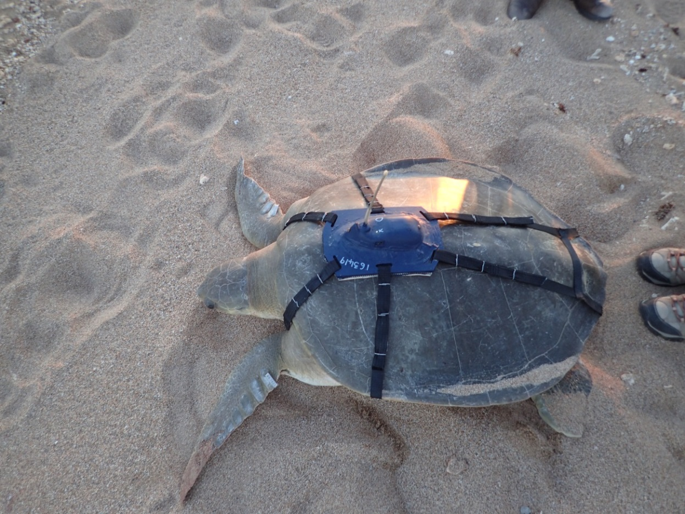

**For more information contact Pilbara flatback turtle research team leader Dr Sabrina Fossette-Halot** [sabrina.fossette-halot@dbca.wa.gov.au](mailto:sabrina.fossette-halot@dbca.wa.gov.au)

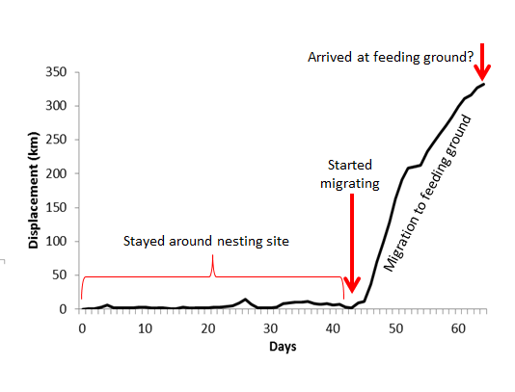

**Distance from beach (km)**

**Days after leaving beach**

Figure 1

Shellington stayed near Thevenard Island for 43 days. On 18 January 2017 she started her migration north towards her foraging grounds.

During this time she travelled an average of 16km a day.

When we lost contact with her she was 332km from Thevenard Island.

She may have just arrived at her feeding ground, offshore Mundabullangana Station (Munda).

Figure 2

Figure 1

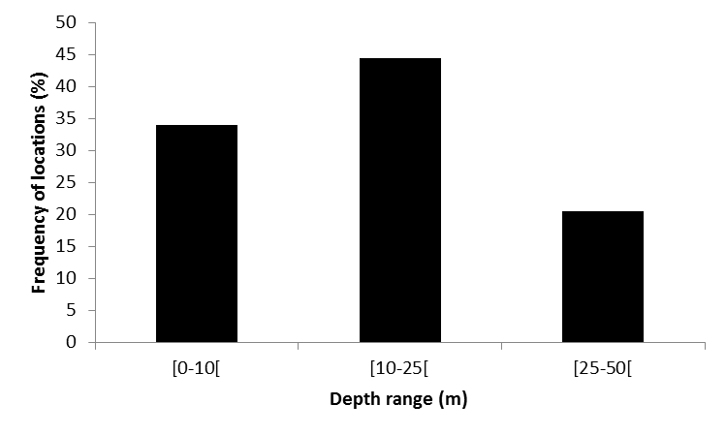

**Depth range (m)**

**Frequency of locations (%)**

Figure 2

Shellington stayed close to shore, within 50km, and in relatively shallow waters – maximum depth of 50m.

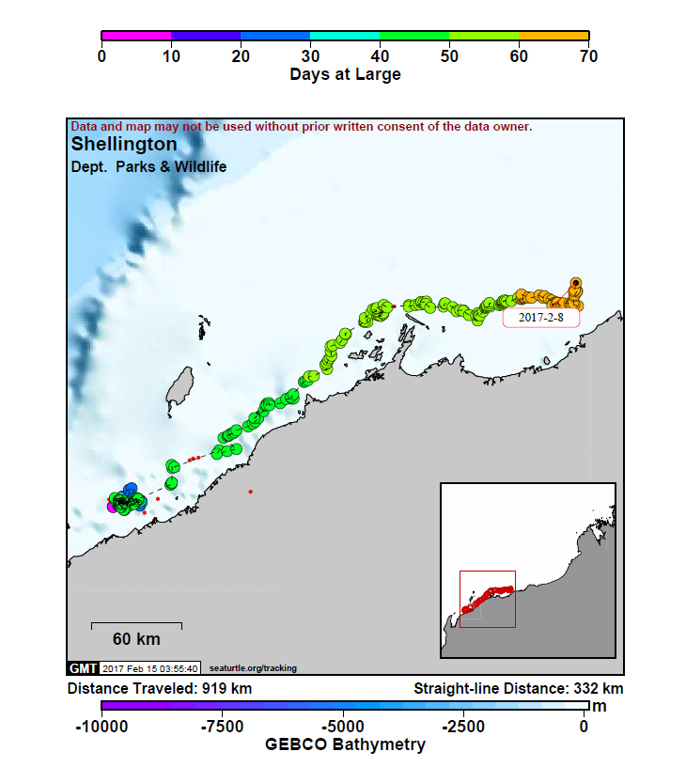

**Thevenard Island**

**Karratha**

**Munda**

**Onslow**

**Shellington was named by the Shire of Ashburton**

On the trail of a turtle

**Meet Shellington, a female flatback turtle with a 85.5cm-long shell.**

On 6 December 2016 she emerged from the ocean and made her way up the beach at Thevenard Island to nest. On her return to the water she was measured and fitted with a satellite tracker.

We followed her for 64 days – until her tracking device stopped transmitting her location on 8 February 2017, possibly due to technical failure. In two months she swam 919km.

**Western Australia**

**Indian Ocean**

Tracked marine turtles can be followed live at <http://www.seaturtle.org/tracking/>

SEATURTLE.ORG collaborates with [Argos](http://www.argos-system.org/applications-argos/wildlife-monitoring/) to help scientists and conservationists manage and analyse their valuable animal tracking data.

***North West Shelf Flatbacks* is a $32.5 million, 30-year conservation program funded by the Chevron-operated Gorgon Gas Project and is administered by the Department of Biodiversity, Conservation and Attractions.**